1. **100% Load**

For the Full- Load condition, the Load resistance is taken as 2.78 Ω. The input and output current properties are shown in Figure X.

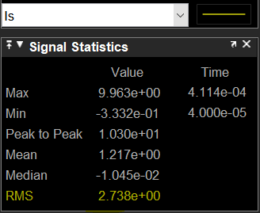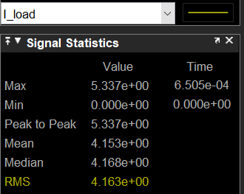

Figure X – Is and Iload currents when the load is 100%.

Vin = 24 V, Vout = 12 V

Is = 2.73 A, Iout = 4.163 A.

Efficiency **η = $\frac{Pout}{Pin}$ = $\frac{12*4.163}{24*2.73}$* 100 = 76%**

1. **75% Load**

For the Full- Load condition, the Load resistance is taken as 3.7 Ω.

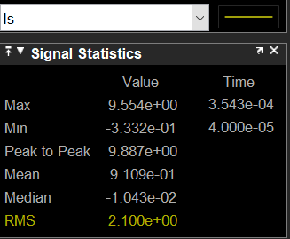 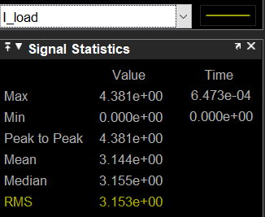

Figure X – Is and Iload currents when the load is 75%.

Vin = 24 V, Vout = 12 V

Is = 2.1 A, Iout = 3.153 A.

Efficiency **η = $\frac{Pout}{Pin}$ = $\frac{12*3.153}{24*2.1}$* 100 = 75.07%**

1. **50% Load**

For the Full- Load condition, the Load resistance is taken as 5.56 Ω.

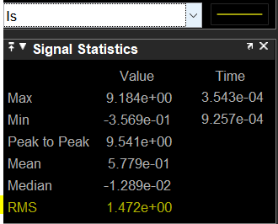 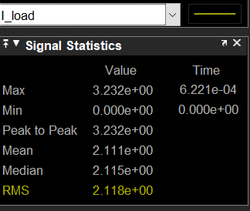

Figure X – Is and Iload currents when the load is 50%.

Vin = 24 V, Vout = 12 V

Is = 1.472 A, Iout = 2.118 A.

Efficiency **η = $\frac{Pout}{Pin}$ = $\frac{12*2.118}{24*1.472}$* 100 = 72%**

1. **25% Load**

For the Full- Load condition, the Load resistance is taken as 11.12 Ω.

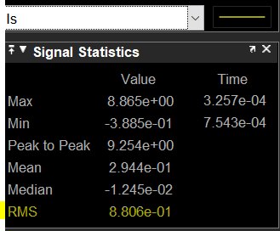 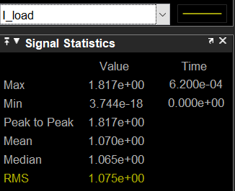

Figure X – Is and Iload currents when the load is 25%.

Vin = 24 V, Vout = 12 V

Is = 0.88 A, Iout = 1.075 A.

Efficiency **η = $\frac{Pout}{Pin}$ = $\frac{12*1.075}{24*0.88}$* 100 = 61%**